FORM 3
THE PATENTS ACT, 1970 (39 of 1970)
and
THE PATENTS RULES, 2003
STATEMENT AND UNDERTAKING UNDER SECTION 8
(See section 8; Rule 12)
1. Name of the applicant(s). |  |  | We¹,  Gujarat Council on Science and Technology (GUJCOST), an Indian entity, having address at Block B, 7th Floor, M. S. Building, Nr. Pathikashram, Sector 11, Gandhinagar, Gujarat – 382011, India  Indian Institute of Technology, Bhubaneswar, an Indian entity, having address at Argul (Jatni), Khordha, Odisha, 752050  hereby declare:
2. Name, address and nationality of the joint applicant. |  |  | - that We have not made any application for the same/substantially the same invention outside India  Or  - that I/We who have made this application No…….dated  …..……..alone/jointly with , made for the same/ substantially same invention, application(s) for patent in the other countries, the particulars of which are given below:
Name of the country | Date of application | Application No. |  |  | Status of the application | Date of publication | Date of grant
NOT APPLICABLE
3. Name and address of the assignee |  |  |  | - that the rights in the application has/have been assigned to no one that we undertake that upto the date of grant of the patent by the Controller,  - that we undertake that upto the date of grant of the patent by the Controller, we would keep him informed in writing regarding the details of corresponding applications for patents filed outside India in accordance with the provisions contained in section 8 and rule 12.  Dated this 16th day of February 2026.
4. To be signed by the applicant or his authorized registered patent agent. |  |  |  | Signature. ………………….  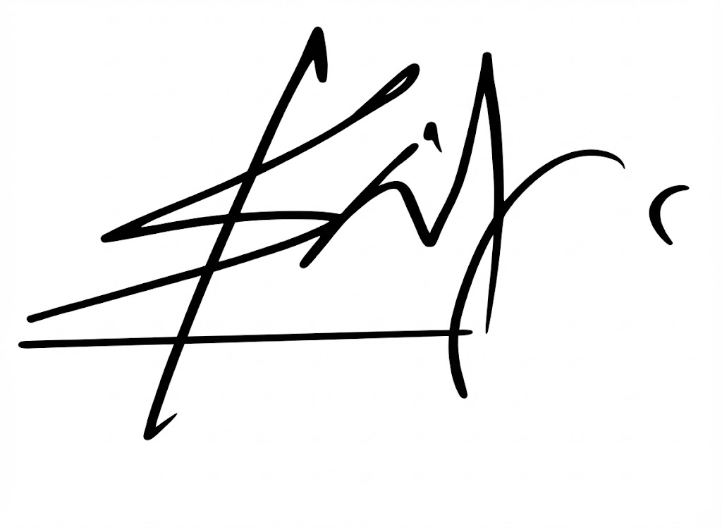  Signature (Prof. Shantanu Pal)
5. Name of the natural person who has signed. |  |  |  | Dr. Narottam Sahoo  Advisor and Member Secretary  Gujarat Council on Science and Technology  Dept. of Science and Technology, GoG.  Prof. Shantanu Pal  Dean Undergraduate,  Indian Institute of Technology, Bhubaneswar
To
The Controller of Patents,
The Patent Office,
At Mumbai
Note: - Strike out whichever is not applicable;

